SecComply Policy Document

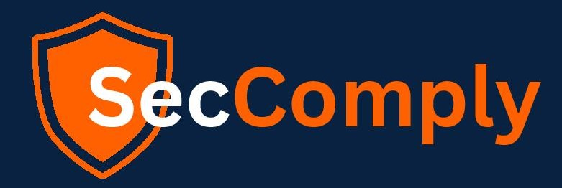

# Acceptance Usage Policy

**Owner: Atharva**

*Generated: 7/4/2025*

This is a policy document for SecComply, owned by Atharva.

This document contains standard policy guidelines and procedures.